
‘

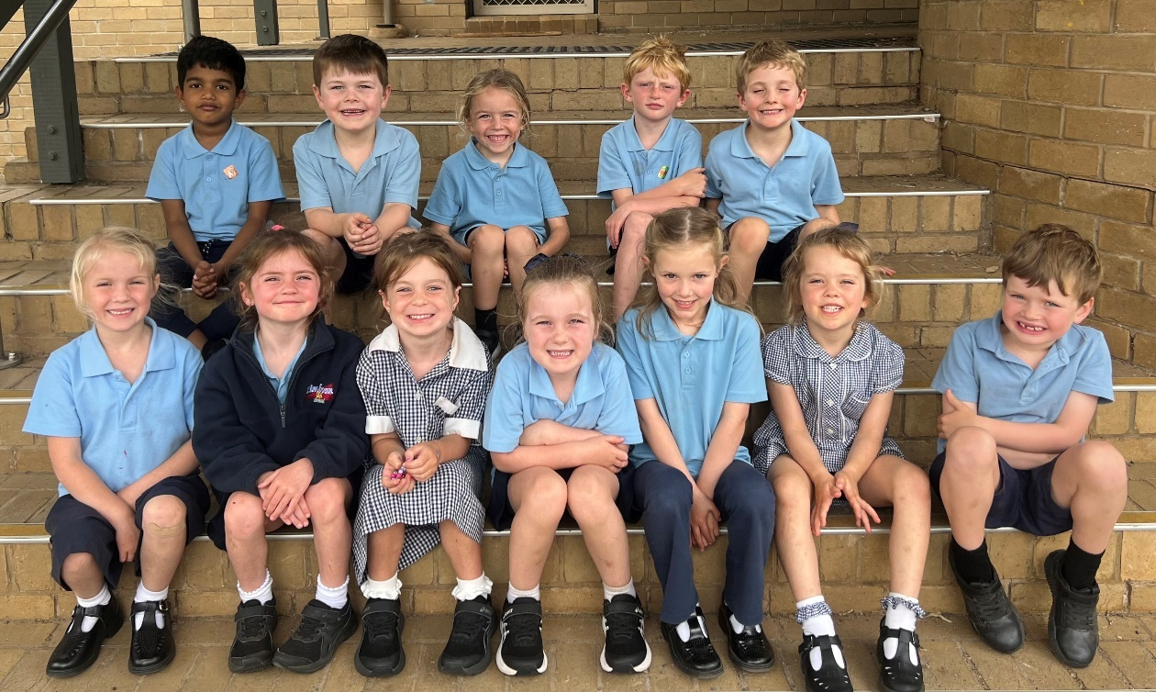
13th February
A group of our new prep students
26: 01
P.O Box 82 Timboon 3268
Telephone: (03) 5598 3381
Email: timboon.p12@education.vic.gov.au
Website: www.timboonp12.vic.gov.au
School Council President: Rebecca McAuliffe
School Captains: Holly Delaney
Vice Captains: Evie Gordon & Noah Clark

KEY SCHOOL DATES
16th February Student Free Day
4th March School Photo Day
2nd April P-12 House Cross Country
3rd April Good Friday / Holidays
20th April Start Term 2
7-12 DATES
11th February Swim Trials Division Swimming
16th February Yr 12 Camp
18th February Yr 11 Sailing Camp
23rd February HSSSD Swimming
26th February 7 & 10 Immunisations
2nd March 7-12 House Athletics
1st April 7-12 Assembly

P-6 DATES
11th February Swim Trials Division Swimming
20th February 3-6 Swimming Carnival
27th February 3-6 Warrnambool Div Swimming
5th March 3-6 House Athletics
Timboon P-12 staff and students acknowledge the traditional owners of the land on which we are gathered today, the Kirrae Whurrong people, and pay our respects to their elders both past and present.



PRINCIPALS’ REPORTS

Welcome to 2026
The start of a new school year always brings a strong sense of optimism, and it has been wonderful to see our school come alive again with the energy of students, staff, and families.
Last week’s welcome interviews provided a valuable opportunity for students and parents to connect with teachers, become familiar with learning spaces, organise lockers, and establish strong foundations for the year ahead. Beginning the year with clarity and partnership sets every student up for success.
I extend a very warm welcome to our new Prep and Year 7 students and families, along with those who have joined Timboon P–12 School across other year levels. Starting at a new school is a significant milestone, and we are proud to support each student as they settle into our community. I encourage everyone to play a role in helping our newest members feel connected and supported.

Looking Ahead: The Wizard of Oz
We are excited to announce this year’s school production, The Wizard of Oz. School productions are a highlight of the Timboon P–12 calendar and reflect the creativity, courage, and collaboration of our students.
Students in Years 3 to 6 will have the opportunity to participate in the ensemble, while students from Years 3 to 11 are invited to audition for lead roles. Productions like this are more than performances; they build confidence, strengthen friendships, and bring our community together in celebration of the arts. We look forward to sharing this journey with families as the year unfolds.

Our Improvement Focus for 2026
At Timboon P–12, our core purpose is to ensure every student thrives in their learning and in their lives. This year, our work is guided by two key improvement priorities:
Strengthening teaching and learning
Teachers are continuing to refine planning processes and explicit teaching practices to ensure all students experience high quality, purposeful learning every day.
Positive classrooms and school climate
We are further developing our School-Wide Positive Behaviour Support approach to create predictable, supportive, and engaging learning environments.
Students have already begun the year by learning and practising our expected behaviours, with an initial focus on entry routines, attentive listening, and following instructions. These foundations maximise learning time and help classrooms run smoothly. A whole-school launch of this work will take place soon, and I look forward to sharing more with you in the coming weeks.

New Routines Supporting Learning and Safety
New bell times and updated bus procedures were introduced at the start of the year. These adjustments are designed to protect learning time while strengthening supervision and safety.
Students have responded positively as they adjust to the updated schedule, particularly the afternoon bus process. Staff continue to refine this routine each day to ensure it operates as smoothly as possible. While there is still some work to do, the early signs are encouraging.
Students are reminded to line up promptly, wait to be marked off the roll, and move sensibly toward their buses. Buses arrive at approximately 3:30pm, and students should not enter the tennis court area once buses begin arriving.
We appreciate the cooperation of students and families as these routines become embedded.

Holiday Works and School Improvements
Several projects were completed over the summer break to enhance our learning environment:
•Refurbishment and painting of a wall in the Junior School 1 building
•Creation of a new section in the woodwork area to house our laser cutter, expanding student learning opportunities in design technologies
•Minor upgrades across Junior School 2 and 3
•Gardening works and the planting of new trees around the top oval
•Expansion of our CCTV system to further support school safety. Information regarding its use is available on our website under Policies
These improvements reflect our ongoing commitment to providing safe, modern, and engaging spaces for students and staff.

School Council Elections 2026
The Timboon P–12 School Council election process will be held early this term. I encourage all parents and guardians to carefully consider whether they are interested in contributing to the school by nominating for election to School Council.
School Council is a legally constituted body that plays an important role in supporting the key directions of the school within centrally provided guidelines and frameworks. Parent representation is a critical part of this work. It ensures community perspectives inform decision making and that school policies and priorities reflect the needs of students and families.
Councillors serve two-year terms, and four parent vacancies have arisen to be filled in 2026.
Parents nominating for School Council are required to hold a current Working with Children Check. If you are interested in nominating and do not currently hold one, you are encouraged to begin this process as soon as possible.
If you are considering nominating and would like to discuss the role or what is involved, please come and speak with me.
If more candidates nominate than there are positions available, all parents and guardians of students at Timboon P–12 School will be eligible to vote for parent members.
Election timeline
Thursday 12 February - Nominations open. Parent nomination forms can be collected from the front office.
Friday 20 February - Nominations close at 3:30pm.
Monday 23 February -The list of candidates and nominators will be posted. Ballot papers will be distributed if more candidates nominate than there are available positions.
Monday 2 March - Ballot closes at 3:30pm.
Tuesday 3 March - Declaration of the poll.

As we begin the year together, I thank our staff for their professionalism and preparation, our families for their continued partnership, and our students for the positive way they have returned to learning.

2026 promises to be a year of growth, opportunity, and achievement. I look forward to sharing it with you.

MATT DODSON
PRINCIPAL

Timboon P-12 School
Presentation Ball Friday 27th March

ASSISSTANT PRINCIPAL REPORTS

Our year so far has included welcome interviews, professional learning days, swimming sports, assemblies and learning, so we have been busy and this seems to be continuing as we look ahead to camps, athletics sports, further professional development with Terry Scott, photo day, NAPLAN, and parent/ teacher interviews in the last week of term.
Our ongoing work with School-Wide Positive Behaviour Support (SWPBS) helps create a positive and supportive learning environment for all students. By encouraging positive behaviours, setting clear expectations, and building strong relationships, we aim to ensure our school is a safe, respectful, and welcoming place for every child, from Prep to Year 12.
Building strong, positive relationships has also been a key focus of our staff learning at the start of the year. This work supports our teaching and learning by helping us create classrooms where students feel safe, supported, and confident to have a go. When students feel encouraged and challenged in the right way, they are more willing to take risks in their learning and keep trying, even when learning feels hard. Working together with clear goals and consistent approaches, we are committed to supporting every student to achieve their personal best.
Thank you to Dean Whitehead for his leadership and organisation of the Swimming Sports. It was great to see such high participation by those who attended, strong house spirit, and great to see parents there to support the day.
At Timboon P–12 School, consistent whole-school routines and shared expectations help us create a positive learning environment, where kindness, respect, commitment, and empathy are at the heart of everything we do. Thank you, for your partnership with our staff in helping make our school community a welcoming place for our students.
SOFIA ALEEM
7-12 ASSISTANT PRINCIPAL

Welcome back to school to all our students, families and staff. I feel proud of how well our students have commenced the school year. They have settled into new classes and school routines calmly and enthusiastically. Our Preps have had an excellent start to school, developing routines and getting started on their learning. Our Year 6 leaders have run their first assembly with a few nerves but also with confidence.
Welcome Interviews provided a valuable opportunity to see your child/ren’s classrooms, meet their teacher/s and share any relevant information that will help us to provide the support they need to be successful.
The new bus routines are aimed at having a more structured and safe approach to getting on to school buses. A reminder for all bus travellers to please notify the office of any changes to travel no later than 2pm on the day. This is important to ensure our bus rolls are correct. Please also ensure that adults are at bus stops on time to collect students from school buses at the end of the day.
Thank you to families for ensuring students are wearing correct uniform, including hats, each day.
Coming up, the years 3-6 swimming program will begin on Wednesday February 18th, with our years 3-6 swimming carnival on Friday 20th.
We have a curriculum day for staff professional learning next Monday February 16th, with no school for students on that day.
We look forward to working in partnership with families again in 2026 to help every one of our students to have a happy and successful year at school.
MICHELLE NORTON
P-6 ASSISTANT PRINCIPAL

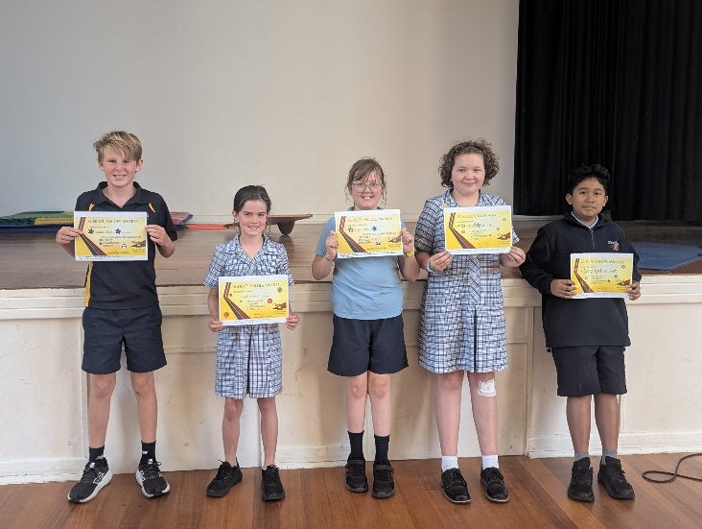

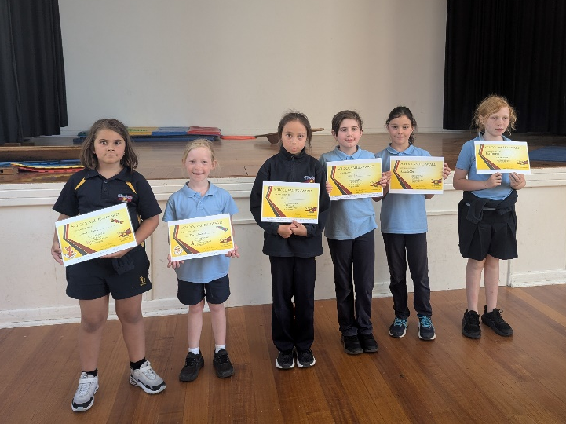

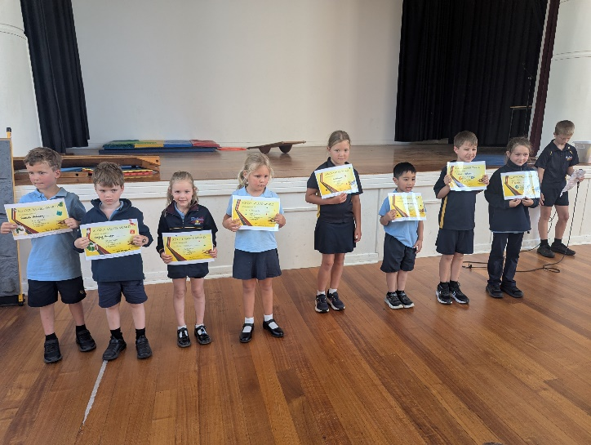

School & Student Insurance Reminder
Parents are reminded that Timboon P-12 School and the Department of Education does not provide personal accident insurance or ambulance cover for students. Parents and guardians of students, who do not have student accident insurance/ambulance cover, are responsible for paying the cost of medical treatment for injured students, including the cost of ambulance attendance and/or transport and any other transport costs incurred. Student accident insurance/ambulance cover policies are available from some commercial insurers and can be obtained by parents or guardians for individual students. Timboon P-12 School and the Department of Education cannot advise parents or guardians on whether to purchase a student accident policy or ambulance cover, or which policy to purchase. It is recommended that they seek assistance in this matter with their insurance broker or find a suitable personal accident insurer online. Personal Property Personal property is often brought to school by students, staff and visitors. This may include mobile phones, iPads, laptops, calculators, toys, sporting equipment and cars parked on school premises. As Timboon P-12 School or the Department of Education and Training does not hold insurance for personal property brought to schools and has no capacity to pay for any loss or damage to such property; students, staff and visitors are discouraged from bringing any unnecessary or particularly valuable items to school. It is highly recommended parents insure personal property.

Outdoor Ed Class fishing this week.
Declan Brumby caught a great fish.

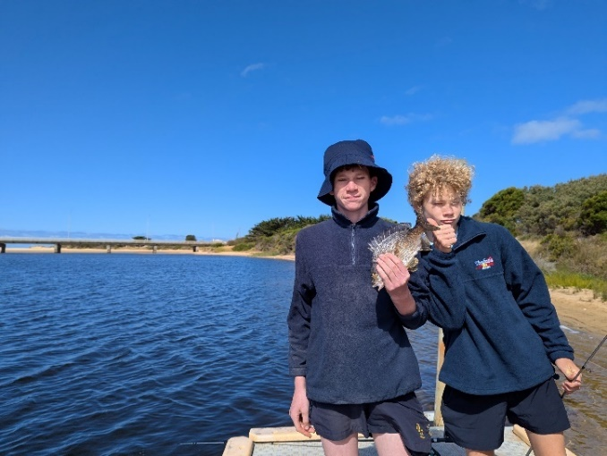

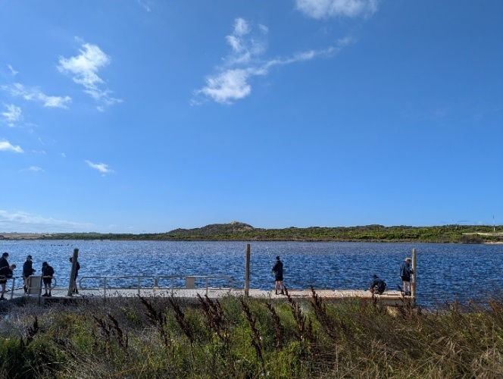

Great day at the 7-12 Swimming Carnival last week.

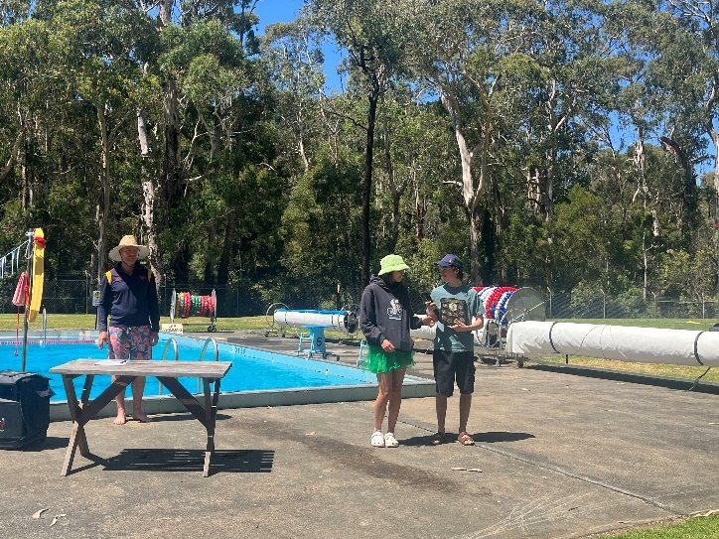

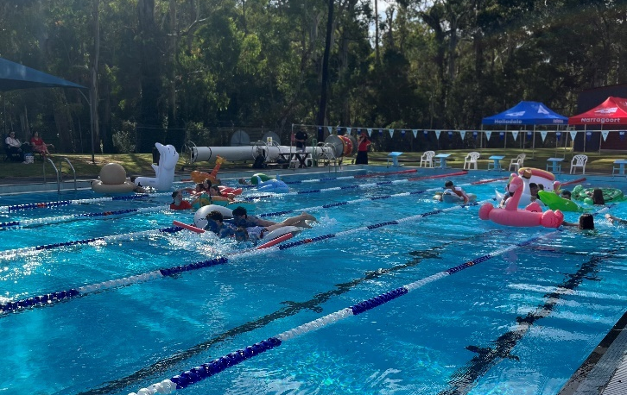

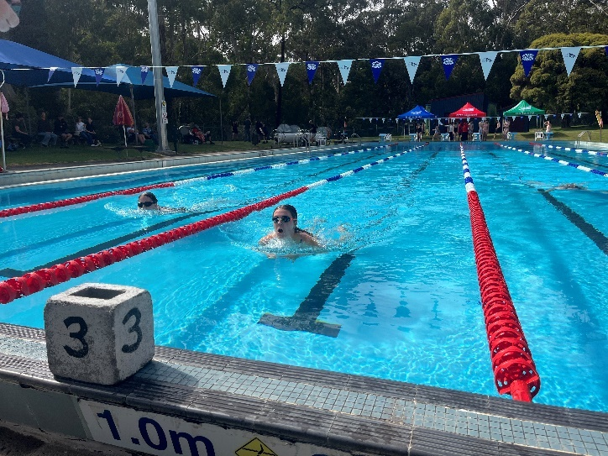

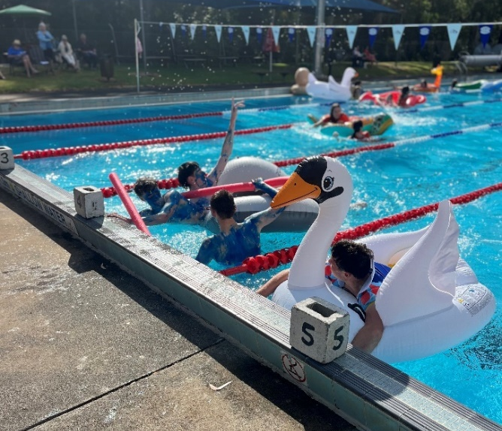

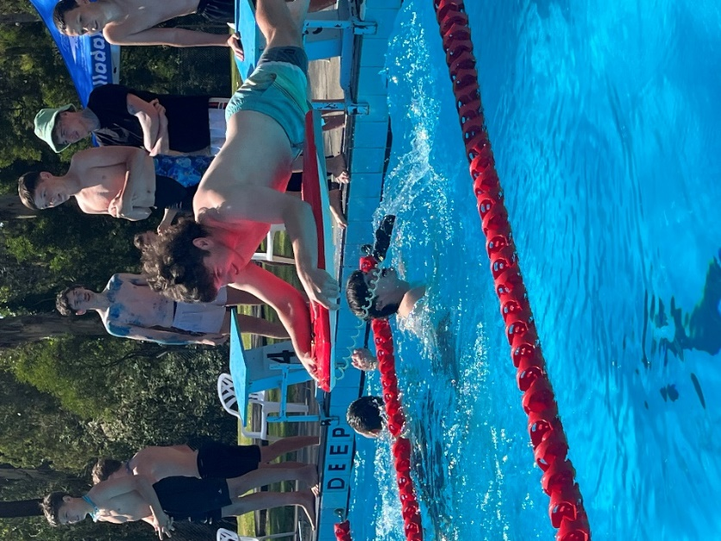

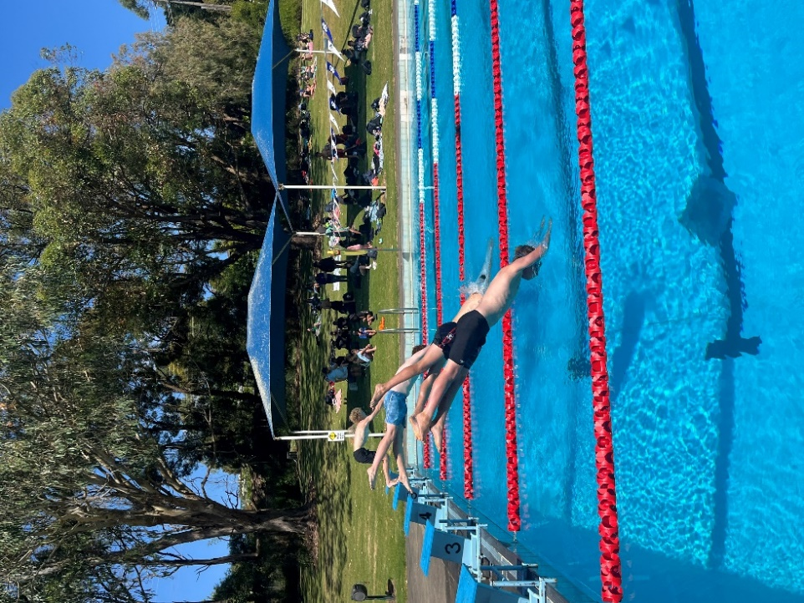

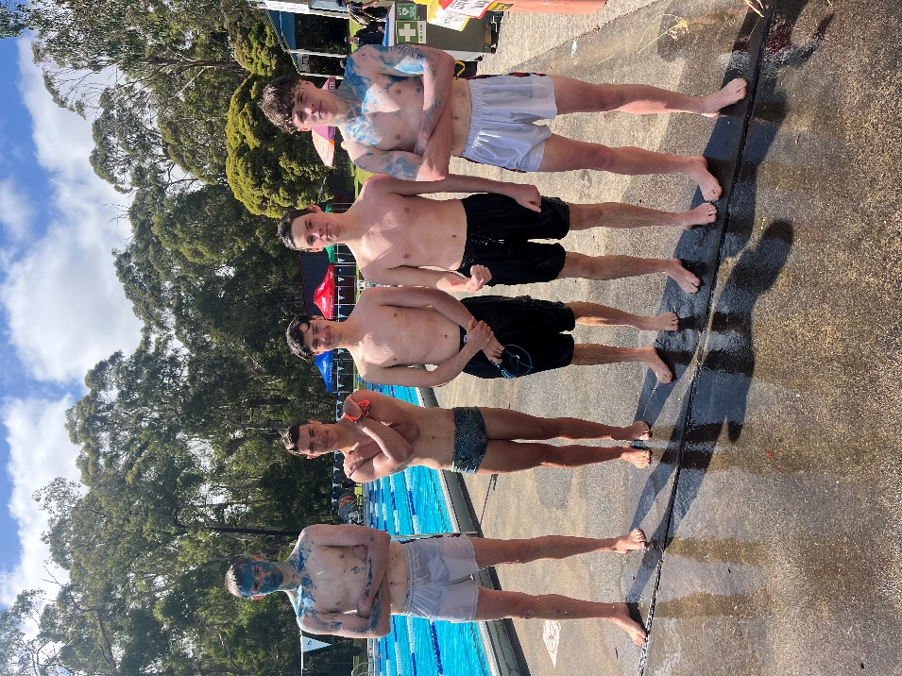

ART ROOM REQUEST
Dear parents,
The primary art room is chasing lids of all shapes and colours for a whole school art project. Think big; such as collecting the lids off the jam jars, milk bottles, old unused drink bottles, texta lids, milo lids, wine bottles, hairspray cans, cream containers, beer lids, lids off random tins, glue stick lids, small biscuit tins etc. In particular we are chasing yellow lids. If we can collect enough, I would love to work on a ‘Wizard of Oz – Yellow brick road’ mural that we can display at our school musical this year and eventually hang outside the school to brighten up a wall. The aim would be for all prep to year 6 students to be able to contribute; either in the painting of the mural on the wood, deciding and designing where to place the lids or using the glue to stick them on. Please feel free to place boxes where you work and one by the bin at home might be a good idea too.
The school musical this year is ‘Wizard of Oz’. We are planning on holding a small competition to help with this design.
After doing a few calculations, I would love if we could aim at trying to collect at least 5000 lids. Any leftover lids at the end will go to the secondary school to be melted down and used in their plastic moulding/extruding machine and turned into useful products. House captains will collect from each classroom weekly. Other students will take turns, sorting colours, sizes and washing the lids if need be.
An extra incentive will be two overall prizes; a $10 voucher to spend at our local ice-creamery and a $10 voucher for the lolly shop. These two prizes will be given to the two students who can either collect the most lids ( a tally book will be keep in the art room ) and for the most unusual lids collected.
Thank you so much for your support. Happy collecting
Cheers Sarah Mackieson (p-6 Art teacher).






Thank you to all the families that have placed LOOP orders and individual orders for your child/ren during Issue 1 2026.

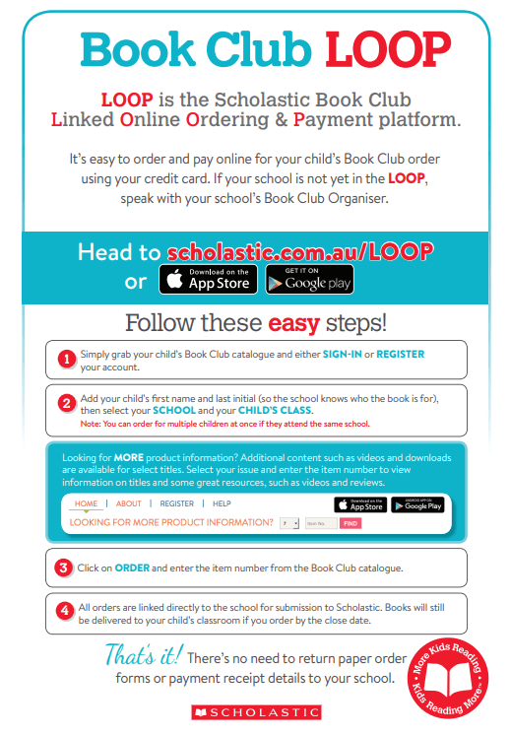



Just a reminder to families that the Library is open each morning from 8:30 am for children to either return or borrow a book.
Children can also use the Library space at recess and lunchtimes to play board games and browse the reading sections.


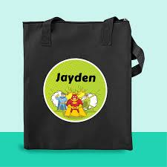

A good sturdy Library Bag for books

Library Sessions

 | Session 1 | Session 2 | Session 3 | Session 4 |  | Session 5
Monday |  |  |  | 01A
Tuesday |  |  | 03A |  |  | 06C
Wednesday |  |  |  | 3/4B | 04C | 1/2B
Thursday |  |  |  | 02C |  | 05A
Friday |  |  | 00A | 00B |  | 5/6B

Keep in mind that we are a combined school and public library and parents and pre-schoolers are very welcome to attend the library and borrow from the collection.
Mrs Clarke

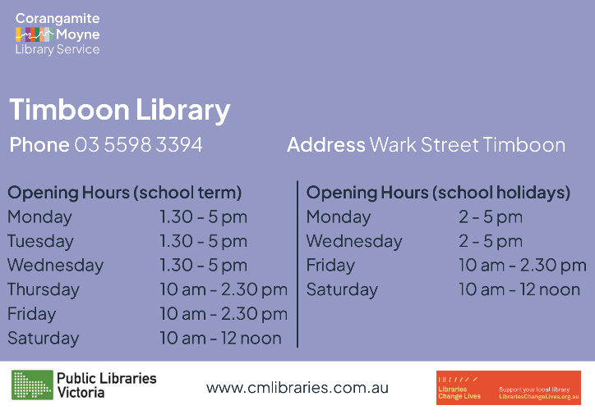

TIMBOON SQUASH CLUB Inc
Mixed Squash Pennant
Tuesday Nights
Seedings 10th & 17th February 2026
Pennant starting 24th February
New players welcome
Men, Ladies & Juniors
Contact: Katrina Currell 0439 995 010

We are looking for more volunteers to join the canteen roster team.
If you have some time free to help us out, please call Cheryl in the Caf

2026 Caf Roster Term 1

Week 4  16th – 20th February | 12:30 pm – 2:30pm
Mon 16th
Tues 17th | Anna Stephens
Wed 18th | Nicole Burvill
Thurs 19th | Tanya McKenzie
Fri 20th | Naomi Lewis

Week 5  23rd – 27th February | 12:30 pm – 2:30pm
Mon 23rd | Bryan Ward
Tues 24th | Amber Donohue
Wed 25th | Olga Caltino
Thurs 26th | Olivia Tutungi
Fri 27th | Kelly Knight  Tanya Campbell

Week 6  2nd – 6th March | 12:30 pm – 2:30pm
Mon 2nd | Linda Whiting
Tues 3rd | Marriann Pender
Wed 4th | Sarha Ferrari
Thurs 5th | Scott Munro
Fri 6th | Tanya Delaney

Week 7  9th – 13th March | 12:30 pm – 2:30pm
Mon 9th | LONG WEEKEND
Tues 10th | Tony Bird
Wed 11th | Cassy Warner
Thurs 12th | Anna Cunnington
Fri 13th | Jen Trigg

WEEK 8  16th – 20th March | 12:30 pm – 2:30pm
Mon 16th
Tues 17th | Rachel Richardson
Wed 18th | Volunteer Required
Thurs 19th | Nichole Burvill
Fri 20th | Bonnie Doolan



Stymie allows bystanders to remain anonymous, giving them the courage to overcome the fears and social pressures that prevent them from speaking up. It also relieves feelings of helplessness for students who want to help themselves or their peers but don't quite know how.
It takes courage to say something.
Stymie empowers young people to ask for help when they need support, or if they are seeing or experiencing harm. Stymie provides online reporting for schools. Encrypted, anonymous notifications are delivered within seconds to authorised recipients, who respond according to their wellbeing framework. The notification provides the option to include screenshots or images that validate the notification. #saysomething on behalf of themselves or as a bystander for someone else
How STYMIE Works
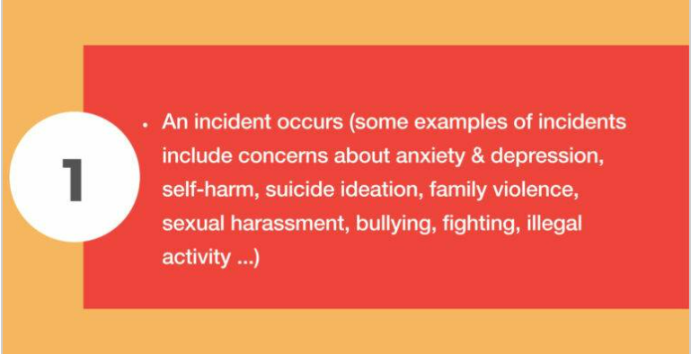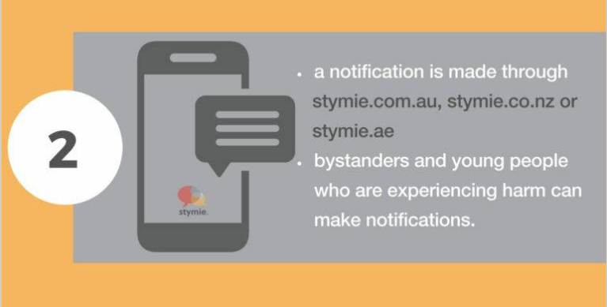
The notification interface allows bystanders to upload evidence like screen shots of FB discussions, Snapchats, text messages or instant message conversations and an outline of the incident(s). https://www.stymie.com.au/.
The STYMIE notifications are received in the form of an email alert to designated leadership staff. The notifications are encrypted, anonymous and confidential. STYMIE does not store any information; they are merely the road upon which it travels.



The Simpson FNC are on the lookout for players in:
🟡 Under 12s
🟡 Under 15s
🟡 Under 18s
We’re a family-focused club with a strong community and great support for our juniors.
📞 Enquiries:
Andrew Crole — 0439 361 782
Jayden McVilly — 0417 776 507
All games played on a Saturday morning.





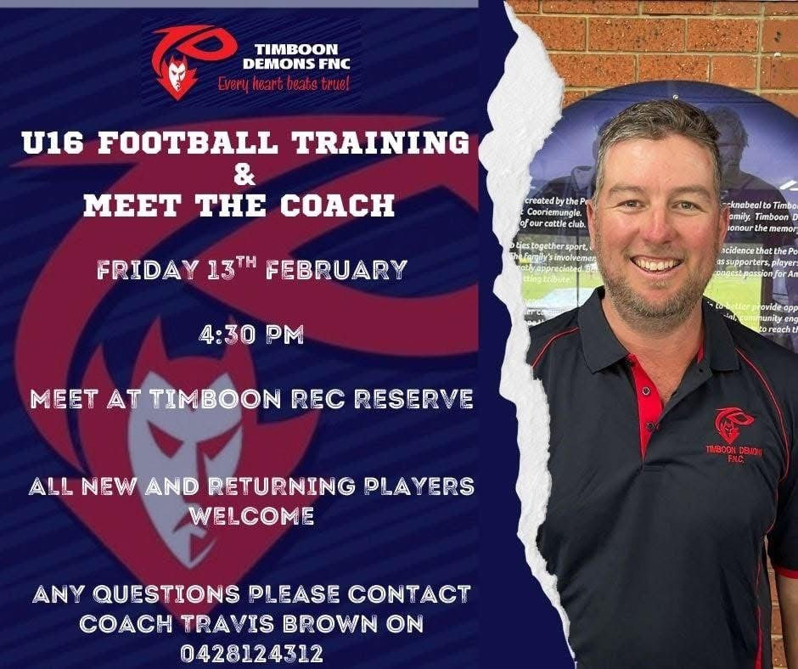

Dear families,

As part of our Harmony Day celebrations this year, we are planning a whole-school event that celebrates the rich cultural diversity within our school community. The event would be scheduled for Friday March 20th.
We are hoping to create a series of cultural stalls where students and families can share aspects of their culture with others. This may include:
- Food stalls (traditional foods or snacks)
- Cultural artefacts or displays
- Traditional dress (students or families willing to showcase cultural clothing)
- Performances (dance, music, storytelling, or other cultural performances)
At this stage, we are simply gauging interest from families who may like to be involved in some way. Participation can be as big or as small as you feel comfortable with.
If you would be interested in:
- Hosting or helping with a stall
- Supporting your child to wear or showcase cultural dress
- Sharing a performance or cultural practice
please let us know by sending an email to lisa.pechotsch@education.vic.gov.au
Further details will be shared once we have a clearer idea of the level of interest.
Thank you for helping us celebrate what makes our school community so special.
Kind regards,
Lisa Pechotsch


